The Summer( )Space Bergsjön 2016 newsletter #3
- Week 29
Our first week in Bergsjön after vacation was packed back to back with interesting activities and meetings, and with no surprise it passed incredibly quickly. Monday morning was dedicated to energizing the group with fun actitivities and recapping what we have done during the first half of the summer, in terms of workshops, tools, meetings and learnings that we can use in our projects or in life in general.
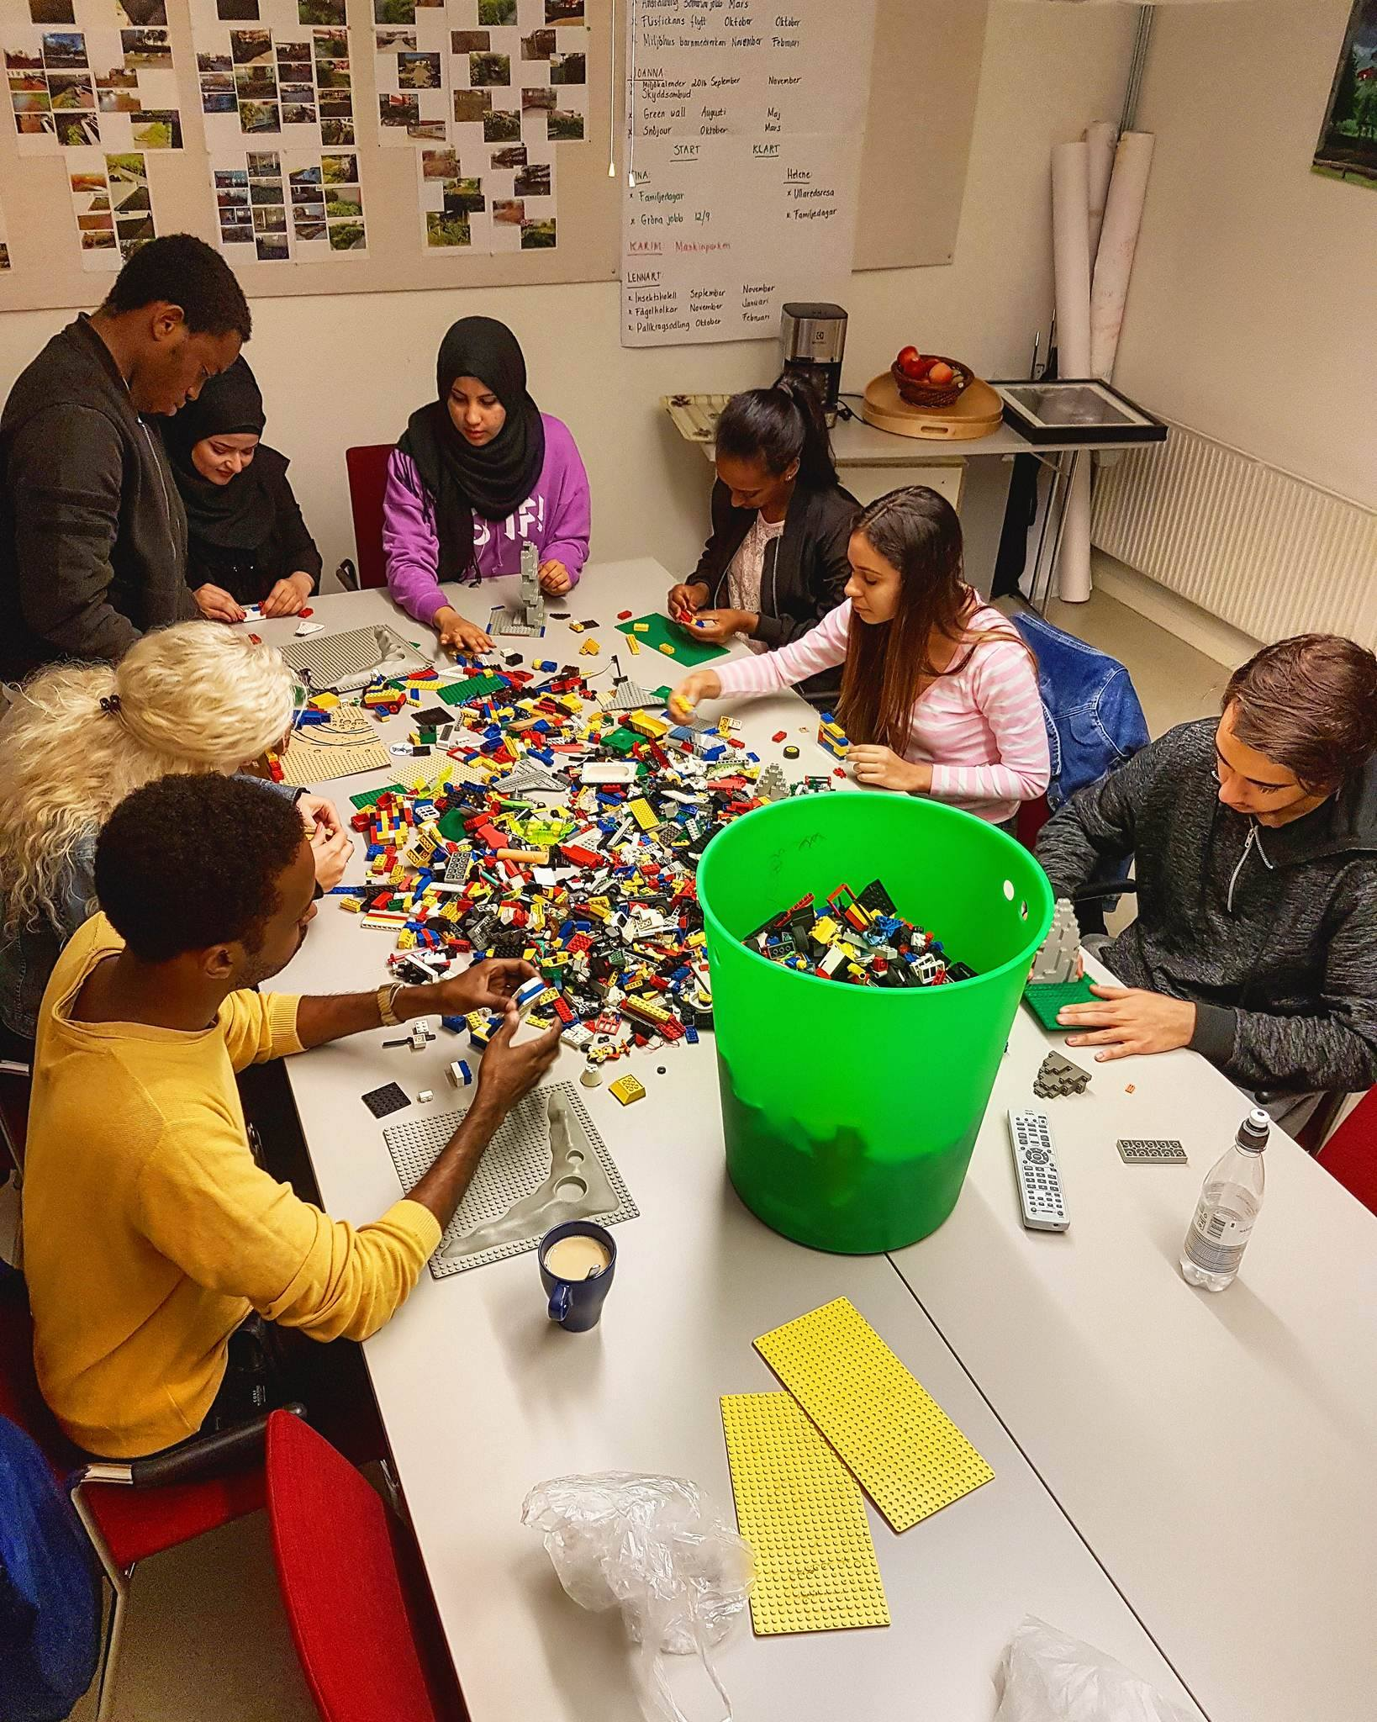
On Tuesday morning we had an interesting workshop on Business Model Canvas creation, which some of the groups will be able to put in practice in their own projects when it gets closer to the end of the whole project. Wednesday morning we then had a workshop on prototyping techniques such as using tangeable materials or design softwares. Later in the week we had a workshop on personal growth without limits. This workshop focused on helping people discover the best version of themselves and to keep going even if they encounter obstacles on the way. The workshop was appreciated and people felt very motivated afterwards.
Figure 1: Prototyping workshop preparation
This week we have started with “walk and talk” workshops, or “walkshops”. These are 30 minutes one-on-one walks where the younger students get a mentor time with Ola Ekman.
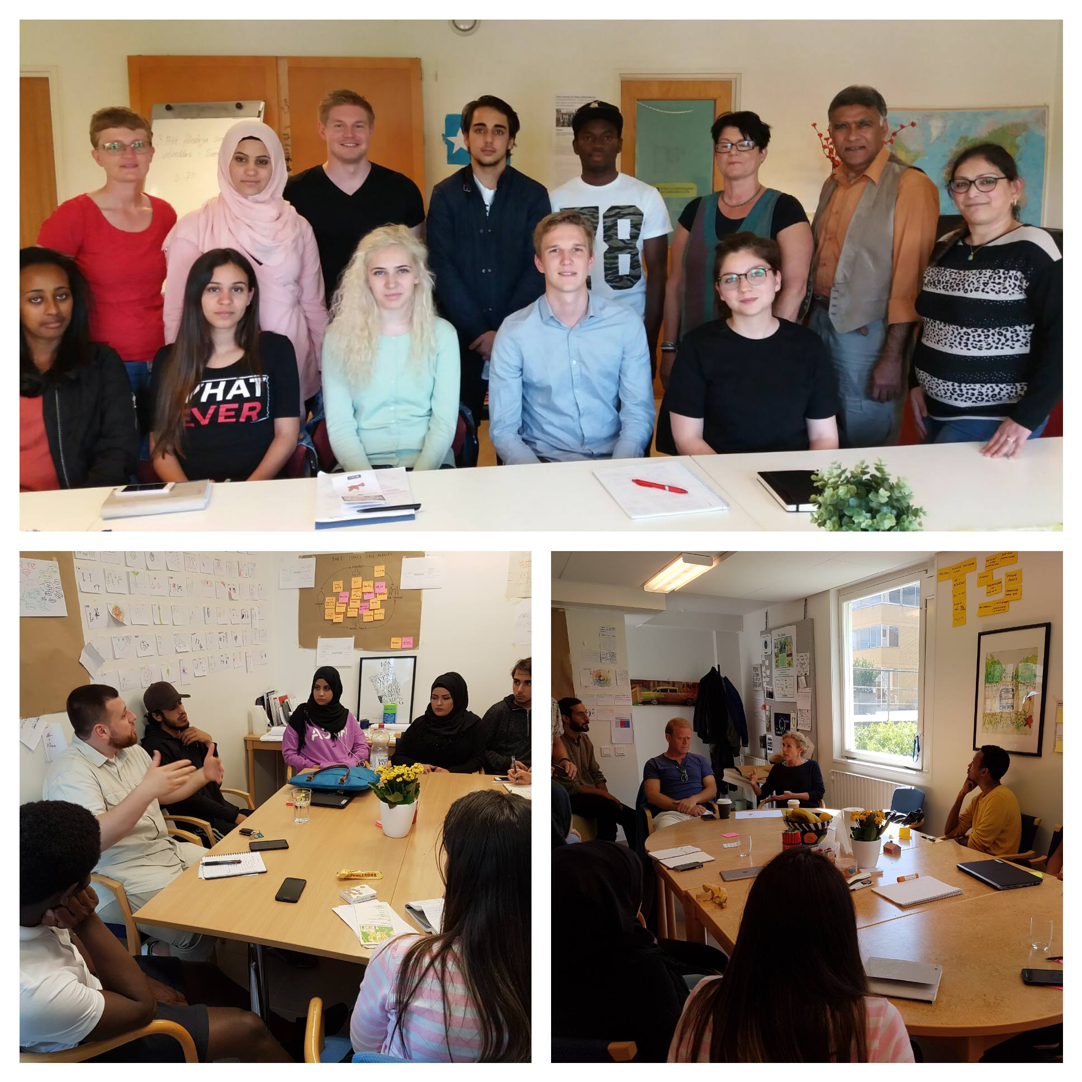
Again we had the pleasure of meeting a lot of people who want to assist us to develop our projects. On Tuesday three of the groups went to visit Kvinnocenter Bergsjön (Women Center) to get information about the area since they are a very well established local organisation that has good connections to the community. We also got many pop-in visits, this week we have met with Tobias Johansson and Björn Osbeck from Familjebostäder, Amanj Aziz from Bergsjöpoolen/Balder and Omar who got a job at Volvo after going through the Bergsjöpoolen program. We also got a visit from Göran Börjesson from Autodesk and Lynelle Cameron who is the President and CEO of Autodesk Foundation and we had a really good chat about our projects.
Figure 2: Visitors this week
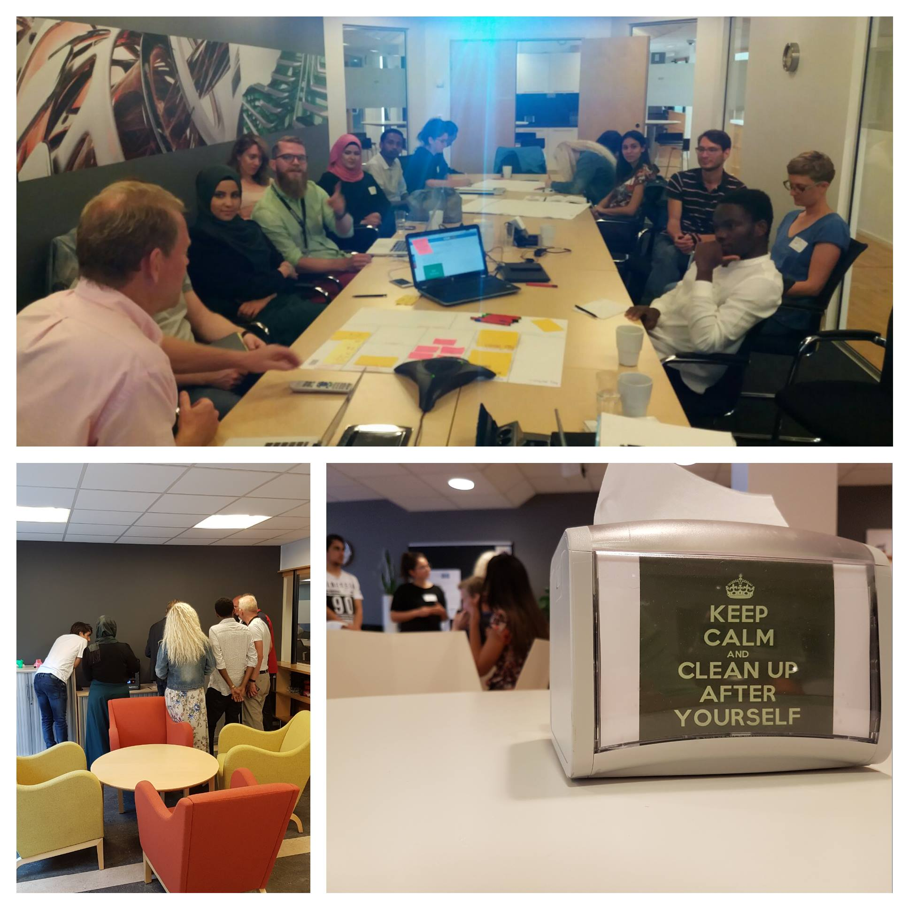
On Thursday we spent the whole day at the Autodesk office where all the fantastic staff there welcomed us and shared what they do at their jobs as well as giving us feedback on our projects that we had presented to them. During the visit we got a conference call from Tomas Karlsson who is the Regional Manager for Autodesk Education. This happened to be the first conference call for many in the room.
Figure 3: Autodesk office
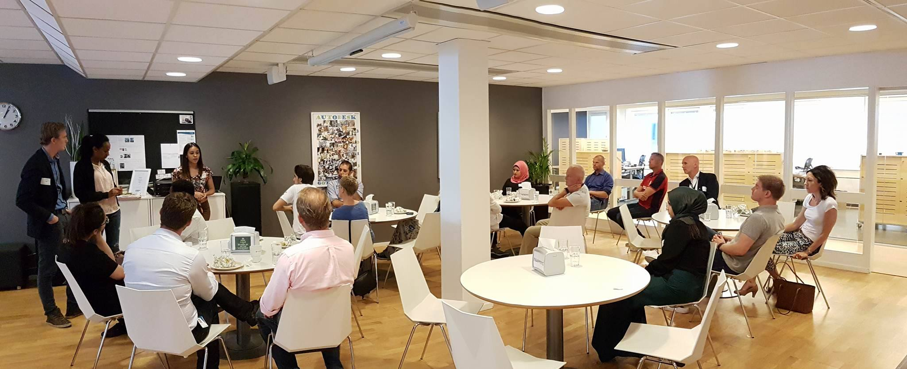
Next week we have a lot of focus on the groupwork so that all the information gathered so far can be evaluated and developed into possible solutions. As always people are welcome to pop in to the office at Rymdtorget 4 and give us a minute of their time.
Figure 4: Presentations for Autodesk staff

Until next time,
The Summer( )Space Team

